Heat pump 4 way reversing valve & compressor failures

Heat pump reversing valve failures can be easily confused with compressor failures. This book will go over the reversing valve and compressor correct operating cycle, troubleshooting each of these components.

By Jeffrey P. Sulzbach

By Jeffrey P. Sulzbach

Heat pump reversing valve & compressor failures

The contents of this publication are presented for informational purposes only, and while
Every effort has been made to ensure their accuracy.

Copyright © 2012. All rights reserved.

No part of this publication may be reproduced or distributed in any form or sold
For profit without the prior written consent of Jeffrey P. Sulzbach

Table of Contents

- Introduction to the 4 way reversing valve
- Parts of the valve
- How the valve operates
- Oversizing & undersizing
- Main causes of reversing valve failures
- Heat Pump Sequence Of Operation
- Introduction to the compressor
- Troubleshooting

Introduction to the 4 way reversing valve

The four-way “reversing valve” was developed, and is in use today. In a heat pump, the compressor may be the main part of the system, but the reversing valve is one of the main components.

Two types of reversing valves were developed, a poppet-type and a slide-type. The slide-type proved to be the better of the two. Poppet-type valves have been obsolete for some years but there is still a chance of finding one in use.
While there are many manufacturers of slide-type reversing valves, their basic construction and operation are the same.

The four-way reversing valve has had many problems. Many customers have complained they had to replace the valve within the first 3-5 years. This is caused heat pump sales to decline.
The way the reversing valve works is the solenoid valve opens pressure ports to operate a nylon slider in the cylinder. This cylinder can jam or bind half way and will over heat the compressor in a few minutes. Once this happens there is little chance that the valve will work again. If the valve is over heated when being installed it is trash and will never move. If the system is very contaminated after a Burnout it may stop the valve from working but there is the possibility of getting it to work again after several cycles. It is possible for the valve to stick in the cooling mode but it is more likely to stick in the heat mode. When the valve sticks half way compressor flooding will cause a burnout in a matter of minutes. We’ll talk more about this later in the book.

Parts of the valve

- Solenoid
- Nose valve & Nylon Slider
- Pilot valve

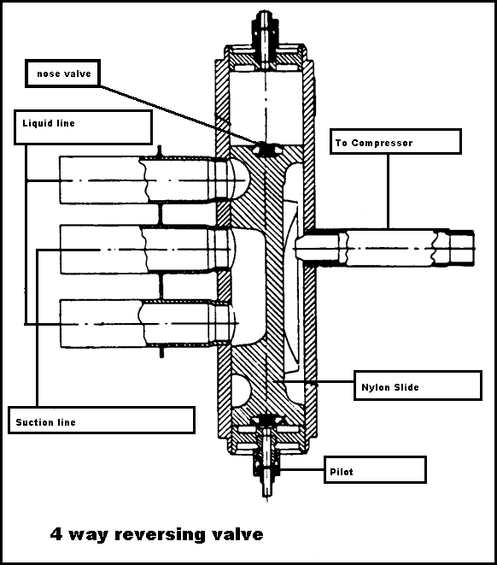

How the valve operates

The reversing valve is the component of a heat pump system that determines whether the system runs in heating or cooling mode. The 4 way reversing valve are two valves in one, the nose valve which switches the refrigerant flow in the system. A pilot valve which controls the nose valve position threw systems pressures. Suction pressure to one end, discharge pressure to the other end, creating a pressure differential which will force the nose valve nylon slide piece to shift in one direction or the other direction. This allows the heat pump system pressures to switch the reversing valve position. Depending on the construction of the heat pump, the reversing valve may be activated by the heat pump through the use of a thermostat, (typically from the "O" terminal).or it may be activated directly by a control board.

Oversizing & undersizing

Oversizing may result in poor or no operation of the reversing valve. A larger than necessary capacity rating will result in a very low pressure drop, possibly so low that the nylon slide will not move, may chatter, or not seat well when the pilot valve is either energized or De-energized. It is the pressure difference across the nylon slide that moves the slide.

Chances are a reversing valve in the selected capacity will have line sizes available to match the valve being replaced. It is not crucial that line sizes match up perfectly. Fittings may be used to increase or decrease the connections to fit the existing tubing. If the replacement valve has a mismatched line sizes, you’ve probably selected the wrong size valve capacity rating.
Undersizing the capacity rating will result in too high a pressure drop, which will cause a loss of BTU capacity of the system.

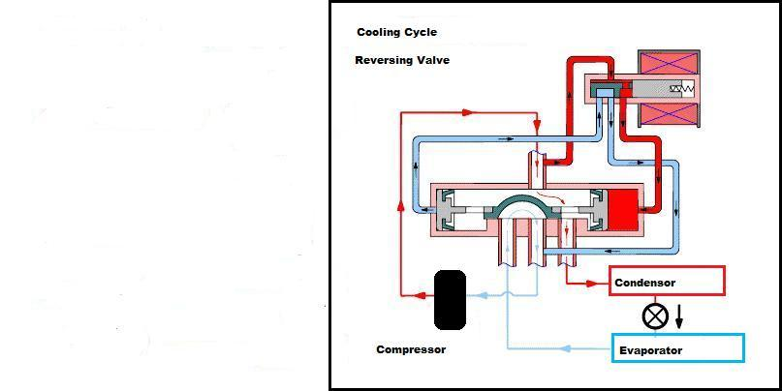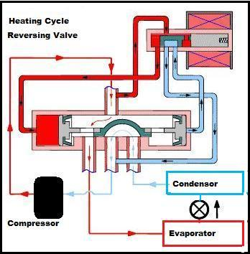

In these pictures it shows the differential pressures in the tubes at the pilot valve. When the solenoid is energized the pilot valve switches. Some solenoids might energize in the cooling mode or in the heating mode.

Main causes of reversing valve failures

The main cause is compressor burnout, over heated reversing valve, an overheated compressor. I also believe here in the South where you cool nine months out of the year, then switch to the heating mode. The reversing valve gets a wax build up or other
Contaminants, that jams the slider from moving or sticking in the half way position.

Reversing valve Electrical Operation

There are two valves in the reversing valve assembly. The solenoid is energized by 24 volts when the thermostat mode is set to heating operation. The nose slide valve is positioned by the pilot valve. Use the ohmmeter to check the 24-volt pilot solenoid. Do not energize the solenoid without the reversing valve pilot stem in place in the coil. Excessive current results in causing solenoid coil failure.

Reversing valve Mechanical Operation

The second part of the reversing valve assembly is a pressure operated nose slide valve. The pilot solenoid valve directs refrigerant pressure to move the nose slide assembly in the valve body. The position of the nose slide valve directs system refrigerant flow to produce heating or cooling at the indoor coil.
A sticking nose valve slide is the most common problem in reversing valves. This is most often caused by contaminants in the valve body caused by using unclean refrigerant lines, or excessive flux and solder material.
Reversing valves that internally leak also cause problems but are rare. A temperature check at the tubes with an electronic temperature tester usually indicates this fault.
Determine the two tubes on the valve carrying cold suction gas. In cooling they are the center and the one connected to the indoor coil. In heating they are the center and the on connected to outdoor coil.

The most common cause requiring reversing valve replacement is compressor burnout. When a compressor burnout occurs, the reversing valve is first in line from the compressor discharge, combustion products leave the compressor. Carbon particles, tar, resins, acids, a wide assortment of burnout products are generated by the breakdown of Freon, oil, and electrical insulation. These vaporized substances find a resting-place in the nearest cooler object the reversing valve, where they condense. Trying to clean a reversing valve is a total waste of time. Actually, the valve has made system clean up after a burnout easier. It contains most of the debris that contaminates the system.

The discharge line connection is always the single port connection on one side of the slide valve. The suction line connection is always the center port on the other side of the slide valve, where there are three connections. The two connections, one on each side of the suction connection, go either to the indoor or outdoor coil, depending on how the system is configured when the pilot valve is energized and De-energized. As showed on the next page.

Heat Pump Sequence of Operation

In order to service and troubleshoot an air-source heat pump system, you must understand the unit's sequence of operation. This is the order of events the system undergoes to cycle itself on and off. Knowing how the unit operates properly helps in determining where to start troubleshooting, when the system does not operate properly. When the system is out of its normal sequence this is a clue to where the problems are.

Cooling Cycle Mechanical Operation

Heat pump cooling operation is similar to the operation of a central air cooling system.
The compressor pumps out high-pressure, superheated refrigerant vapor. The vapor leaves the compressor and passes through the reversing valve. It flows through the outdoor vapor line to the finned outdoor coil. Air from the outdoor fan removes heat from the refrigerant vapor. When enough heat is removed, the vapor condenses into a high-pressure liquid. The liquid temperature is slightly warmer than ambient air temperature. This warm, high-pressure liquid leaves the outdoor coil, and flows through the copper refrigerant liquid line. At the end of the liquid line, the refrigerant passes through a metering device, reducing its pressure and temperature. As the liquid, under reduced pressure, enters the indoor coil surface, it expands and absorbs heat from the indoor air passing over the finned surface. Heat, from the indoor air, causes the low-pressure liquid to evaporate and cools the indoor air. The refrigerant is now a cool vapor. The refrigerant vapor travels through the insulated vapor line to the reversing valve. The reversing valve directs the refrigerant into the accumulator. The accumulator controls liquid refrigerant and refrigerant oil flow back to the compressor. Refrigerant vapor flows through the suction line to the compressor. The cycle then repeats.

Electrical Operation

The electrical cycle is also similar to a central air cooling system.
The thermostat calls for cooling. This sends a 24-volt signal through the "Y" terminal to the compressor contactor in the outdoor unit. The compressor and outdoor fan start. At the same time a 24-volt signal flows through the "G" terminal to the indoor blower relay. The indoor blower starts. The cooling system is now in operation. The thermostat satisfies and ends the call for cooling. This ends the 24-volt signal to the compressor contactor and the outdoor unit stops. This ends the 24-volt signal to the indoor blower relay and the indoor blower stops. The system is now off.

Heating Cycle Mechanical Operation

System operation is basically the same as during the cooling cycle. The difference is the position of the reversing valve that reverses refrigerant flow.
Setting the thermostat to the heat mode automatically powers the solenoid valve in the reversing valve. The compressor pumps out high-pressure, superheated refrigerant vapor. The vapor leaves the compressor and passes through the reversing valve. Refrigerant flows through the insulated, indoor vapor line to the finned indoor coil. Air from the indoor blower removes heat from the refrigerant vapor warming the indoor air and heating the house. When enough heat is removed, the vapor condenses into a high-pressure liquid. The liquid temperature is slightly warmer than indoor air temperature. This warm, high-pressure liquid leaves the indoor coil, flows through the small copper refrigerant liquid line, and exits the building. At the end of the liquid line, the refrigerant passes through a metering device in the outdoor coil, reducing its pressure and temperature. As the cool liquid, under reduced pressure, enters the outdoor coil surface, it expands and absorbs heat from the outdoor air passing over the finned surface. Heat, from the outdoor air, causes the low-pressure liquid to evaporate. The refrigerant is now a cold vapor. The cold refrigerant vapor travels through the larger, outdoor vapor line to the reversing valve. The reversing valve directs the refrigerant into the accumulator. The accumulator holds liquid refrigerant and refrigerant oil and controls their flow back to the compressor. They flow out through a small port inside the accumulator bottom. Refrigerant vapor flows through the suction line to the intake of the compressor. The cycle then repeats.

Electrical Operation
The heating electrical cycle is similar to the cooling cycle.
Setting the thermostat to the heat mode automatically powers the reversing valve solenoid. The thermostat calls for first stage heat.
This sends a 24-volt signal through the "Y" terminal to the compressor contactor in the outdoor unit. The compressor and outdoor fan start. At the same time a 24-volt signal flows through the "G" terminal to the indoor blower relay. The indoor blower starts. The heating system is now in operation. If first stage heating is not enough to heat the building, the second stage thermostat bulb makes a call for more heat. A 24-volt signal flows through the "W2" terminal to the heating relay in the indoor air handler. This sequencing relay cycles on electric elements to add more heat to the indoor air stream. As the building warms, the second stage call for heat ends. This breaks the 24-volt signal to the "W2" terminal and De-energizes the heating relay. The electric heat element(s) cycle off. The first stage thermostat call satisfies and ends the call for heat. This ends the 24-volt signal to the compressor contactor and the outdoor unit stops. This ends the 24-volt signal to the indoor blower relay and it stops. The system is now off. The reversing valve pilot solenoid stays energized as long as the thermostat is set for heating.

Defrost Cycle Mechanical Operation

In heating mode, the outdoor coil is the evaporator. Moisture from the outdoor air condenses on the cooler coil and normally runs off. During the colder part of the heating season, this moisture freezes and blocks air movement through the coil. The frost is removed in the defrost cycle.
The heat pump operates in the heating mode. The defrost control detects the buildup of ice on the outdoor coil. The reversing valve solenoid De-energizes, directing hot gas from the compressor to the outdoor coil to defrost. The outdoor fan stops. If it didn't, cold air from the fan prevents the melting effect of the hot refrigerant. As the temperature of the indoor air drops, controls energize the electric heat elements to warm the indoor air. When the defrost control detects the ice has melted, it terminates the defrost mode. The reversing valve shifts to the heating position and directs hot refrigerant gas to the indoor coil. The outdoor fan operates. The electric elements cycle off. The unit is now in the normal heating mode.

Electrical Operation
A defrost control must recognize when there is a layer of ice on the outdoor coil and when that ice must be removed. There are several different types of defrost controls. While they vary in the methods used to recognize when defrost is necessary, they all take the same action. These controls also must determine when the ice is gone and terminate defrost.
The defrost control initiates a defrost cycle when ice builds up on the outdoor coil. The control energizes the on-board defrost relay with 24 volts. The defrost relay contacts open to De-energize the reversing valve. The defrost relay contacts break power to the outdoor fan. The defrost relay powers the heat relay to bring on the indoor electric heat. After the ice is defrosted, the defrost control terminates the defrost cycle by De-energizing the defrost relay. The defrost relay contacts close sending 24 volt power to the reversing valve and the valve returns to the heating position. The defrost relay contacts close sending power to the outdoor fan. The defrost relay contacts open breaking 24 volt power to the indoor heating relay. The heat pump is now in the normal heating mode.

Emergency Heat Mechanical Operation

The emergency heat setting on the heat pump thermostat is manually selected by the equipment owner. This is usually in response to a malfunction in the outdoor unit. Doing so locks out the outdoor unit. The indoor auxiliary heating system must provide the heat required. Setting the thermostat to the heat position allows the outdoor unit to operate. Due to the expense of electric resistance heating compared to the efficiency of the heat pump, repairs should be made as soon as possible.
Manually select the emergency heat position on the thermostat. The outdoor unit stops all operation. On a call for heat, the indoor unit becomes the sole heat source.

Electrical Operation

Setting the thermostat for the emergency heat mode De-energizes the compressor contactor in the outdoor unit and the indoor blower relay. A call for heat energizes the heating relay in the indoor air handler. This brings on the electric heating elements.
In some cases, selecting emergency heat also powers an emergency heat relay. This relay's contacts electrically bypass any outdoor thermostats used to stage the electric heat elements. This provides the thermostat with full heat from the indoor electric elements.
Moving the thermostat selector to the emergency heat position breaks the electrical circuit to the compressor contactor and the indoor blower relay. This action powers the red emergency heat warning light. A thermostat heat call energizes the electric heat relay. The electric heat relay contacts close powering the heat elements and the indoor blower. The heat call ends and the thermostat De-energizes the electric heat relay. The electric heat relay contacts open De-energizing the electric elements and indoor blower. Moving the thermostat selector to the heat position completes the circuit to the compressor contactor and indoor blower relay. The red emergency heat light goes out.

Introduction to the compressor

Reciprocating and scroll compressors are widely used in heat pumps. The reciprocating compressor stroke cycle is. When the piston moves downwards, it reaches a position where suction pressure vapor is drawn in through the suction reed valve, which is opened automatically by the pressure difference between the cylinder and the suction chamber. The vapor keeps flowing in during the suction stroke as the piston moves towards the bottom, filling the cylinder volume with vapor at suction pressure. After reaching the Bottom, the piston starts to move in the opposite direction, the suction reed valve is closed, the vapor is trapped, and its pressure rises as the cylinder piston moves to the top. Eventually, the pressure reaches the pressure in the discharge chamber, and the discharge reed valve is forced to open. After the opening of the discharge reed valve, the piston keeps moving towards the top, emptying the cylinder into the discharge line.
Reed valves are one or the main parts in hermetic compressors. These valves are called automatic because they open and close depending on the pressure difference between the cylinder and the suction discharge chamber. These reed valves get weak over time and break very easily when flooding the compressor.

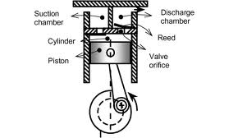

Manufactures have moved on to the scroll compressors now. They can handle flooding because they have no reed valves.

Scroll Compressor

The scroll compressor works on the principle of trapping the refrigerant vapor and compressing it by gradually shrinking the volume of the refrigerant. The scroll compressor uses two scroll configurations, mated face-to-face, to perform this compression process. The tips of the scrolls are fitted with seals and a layer of oil, to help prevent the compressed refrigerant vapor from escaping through the mating surfaces.

The upper scroll, called the stationary scroll, contains a discharge port. The lower scroll, the rotating scroll, is connected to a motor by a shaft and bearing assembly. The refrigerant vapor enters through the outer edge of the scroll assembly and discharges through the port at the center of the stationary scroll. The center of the scroll bearing and the center of the motor shaft are offset. This offset causes an orbiting motion to the driven scroll. Rotation of the motor shaft causes the moving scroll to orbit and not rotate on the shaft. This orbiting motion causes the mated scrolls to form pockets of refrigerant vapor. As the orbiting motion continues, the relative movement between the orbiting scroll and the stationary scroll causes the pockets to move toward the discharge port at the center of the assembly, gradually decreasing the refrigerant volume and increasing the pressure.

Three revolutions of the motor shaft are required to complete the compression process.

During the first full revolution of the shaft, or the intake phase, the edges of the scrolls separate, allowing the refrigerant vapor to enter the space between the two scrolls. By the completion of first revolution, the edges of the scrolls meet again, forming two closed pockets of refrigerant.

During the second full revolution, or the compression phase, the volume of each pocket is progressively reduced, increasing the pressure of the trapped refrigerant vapor. Completion of the second revolution produces near-maximum compression.

During the third full revolution, or the discharge phase, the interior edges of the scrolls separate, releasing the compressed refrigerant through the discharge port. At the completion of the revolution, the volume of each pocket is reduced to zero, forcing the remaining refrigerant vapor out of the scrolls.

Looking at the complete cycle, notice that these three phases—intake, compression, and discharge—occur simultaneously in an ongoing sequence. While one pair of these pockets is being formed, another pair is being compressed and a third pair is being discharged.

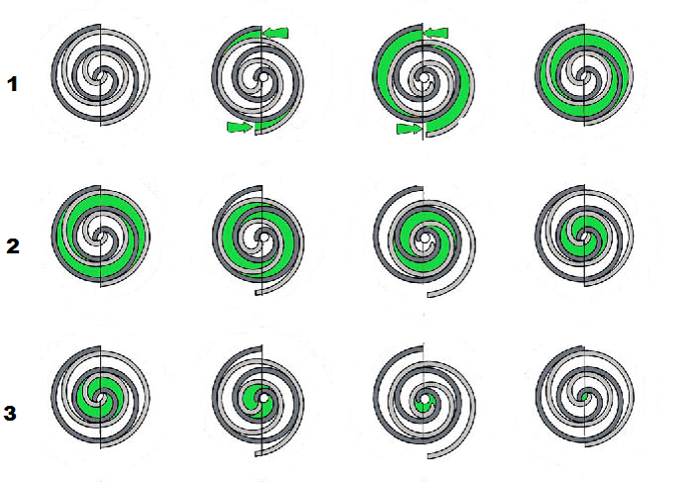

The scroll compressors are widely used in heat pumps, split systems and self-contained units. They handle liquid flooding better, they have no reeds valves to break.

Troubleshooting

Troubleshooting mechanical or electrical problems in a scroll
Compressor is the same as for a reciprocating compressor, except
The scroll compressor should never be allowed to pump into a
Vacuum. If a pump down procedure is used, the scroll compressor is capable of pumping into a vacuum very quickly, which could cause compressor failure. Some scroll compressors have a discharge thermostat that reciprocating compressors don’t have. This thermostat is mounted in the top of the compressor shell to sense if the discharge temperature reaches 290°F and shuts down the compressor to prevent damage to the compressor. When the temperature of the thermostat reaches 140°F, power is restored to the compressor. To determine if the thermostat is operating properly, attach the thermocouple of an electronic thermometer to the dome of the compressor near the thermostat.
The electronic thermometer must be capable of reading at least 300°F. Start the unit and let it run for at least 15 minutes to obtain normal operating conditions. Watch the thermometer to see if it is approaching 270°F. If your thermocouple is located on the dome near the discharge thermostat, there could be a 20° difference between well temperature and dome temperature. If the temperature rises to 270°F, repair the system problem such as low charge, blocked condenser coil, if the temperature does not rise 270°F, replace the thermostat.
When an air conditioning compressor has burned out by shorting of internal components - it will fail to start at all. This failure is detected by disconnecting all power and wiring from the unit and measuring resistance between the motor start ,common and run terminals.
If there is zero resistance the winding is open or broken.
If you measure the resistance across a compressor winding and your meter's is reading “OL” on a digital meter and that would indicate the compressor winding is open (burned through). The same effect can be observed from simply connecting the meter to absolutely nothing. Typically if just one winding is open you'll see “OL” resistance at one terminal. For the non-open windings you will read zero resistance. Continuity between the Common terminal and the Start or between the Common terminal and Run terminal.
If the resistance measured across the air conditioning compressor winding are too close to 0 ohms, it's shorted. The compressor should blow the fuse or trip the circuit breaker when power is turned back on. If there is resistance but not infinite resistance between the motor terminal and the motor casing, the motor has become shorted to ground internally and the unit needs to be replaced. If there is no resistance between the start and run terminals to common, but there is resistance between the start and run terminals, this means that the internal motor overload protection circuit is open. In this last case, allow the motor to cool and re-test it before trying to replacing it.
A compressor may pass all of these electrical tests and still require replacement. The tests above only test electrical connections and windings. A heat pump compressor that has jammed up mechanically internally will still refuse to start and maybe will hum. When all of the electrical tests are complete contactor relay, start capacitor, run capacitor are tested and are okay. It may also not be frozen, that is its internal electrical motor may start and run, but the compressor fails to produce any refrigerant pressure at its outlet side. In this case internal parts or valves in the unit have broken without jamming the motor itself. In this case, all of the electrical components and tests will look okay. It may make a rattling or clanking sound and needs replacement. It will continue to run but could burnout at any time. A compressor with bad internal valves will continue to run but is inefficient and should be replaced. The symptom is very easy the pressures equalization of high and low side pressure as soon as the motor stops. Bad reed valves will be unable to pull pressure down on the low side of the system. A leaky discharge reed valve on the compressor output side pulls hot gases back into the compressor cylinder and recompresses them, causing abnormally high head pressures at the compressor motor. And as a result the compressor won't be able to move vapor.
HVAC compressors do fail and need replacement, but only when you have tested and ruled out the other 80% of the causes of heat pump problems usually electrical ones, you go ahead and replace the compressor unit. A failed compressor or condenser fan can cause the Heat pump system to shut down due to an overheating compressor or excessive pressures developed inside the compressor. If your compressor or condenser unit does not include a safety override switch to perform this shutdown and if the condenser unit fan is not working, your compressor motor may be permanently damaged.

Troubleshooting Compressors
When a compressor is suspected of being defective, a complete
analysis should be made of the system before the compressor is
Replaced. In some cases, the symptoms encountered in servicing an air conditioner may lead the serviceperson to suspect the compressor. Actually the trouble is in another section of the system.
For example, noise and knocking are often incorrect belt alignment, air in the system, or a large quantity of oil
pumped through the compressor because of liquid refrigerant is
in the crankcase.
The most common operating problems with air-conditioning compressors are.
Compressor does not start or no humming.
(a) Open power switch. (a) Close switch.
(b) Fuse blown. (b) Replace fuse.
(c) Broken electrical connection. (c) Check circuit and repair.
(d) Overload stuck. (d)Wait for reset; check current.
(e) Frozen compressor or motor (e) Replace the compressor.
bearings.
(f) High head pressure; cut out (f) Push high-pressure button and
open due to high pressure. check for air circulation in
condenser.
(g) Central contacts in open (g) Repair and check control.
position.
(h) Open circuit in compressor (h) Replace the compressor.
stator.
(i) Thermostat set too high. (i) Reset to proper level.
(j) Solenoid valve closed. (j) Examine holding coil; if
burned out, replace.
Compressor starts but motor will not get off of starting windings; high
amperage and rattle in the compressor.
(a) Compressor improperly wired. (a) Check wiring against wiring
diagram; rewire if necessary.
(b) Low line voltage. (b) Check line voltage and correct
(decrease load on line or
increase wire size).
(c) Relay defective. (c) Replace relay.
(d) Run capacitor defective. (d) Replace run capacitor.

Symptom and Possible Cause Possible Remedy
(e) Compressor motor starting (e) Replace compressor.
and running windings shorted.
(f) High discharge pressure. (f) Correct excessive high pressure.
(g) Starting capacitor weak. (g) Check capacitor; replace if
necessary.
(h) Tight compressor. (h) Check oil level and correct, or
replace compressor.
Compressor will not start; hums and trips on overload.
(a) Compressor improperly (a) Check wiring against wiring
wired. diagram; rewire if necessary.
(b) Low line voltage. (b) Check line voltage and correct.
(c) Starting capacitor (c) Replace capacitor.
defective.
(d) Relay contacts not closing. (d) Check contact points; replace
if defective.
(e) Grounded compressor (e) Replace compressor.
motor or motor with open
winding.
(f) High discharge pressure. (f) Check excessive high pressure.
Check air.
(g) Tight compressor. (g) Check oil level and correct, or
replace compressor.
Compressor starts and runs but short cycles.
(a) Low line voltage. (a) Check line voltage; correct.
(b) Additional current passing (b) Check wiring diagram;
through overload fan motors may be
protector. connected to the wrong
side of the protector.
(c) Suction pressure high. (c) Check compressor for possibility
of misapplication.
(d) High discharge pressure. (d) Correct excessive high
pressure.
(e) Run capacitor defective. (e) Check capacitor and replace.
(f) Compressor too hot; (f) Check refrigerant charge; add
inadequate motor cooling. if necessary.
(g) Compressor motor (g) Replace compressor.
windings shorted.
Symptom and Possible Cause Possible Remedy
(h) Overload protector (h) Check current, give reset time;
defective. if it does not come back, replace
compressor.
(i) Compressor tight. (i) Check oil level and correct, or
replace compressor.
(j) Discharge valve defective. (j) Replace compressor.
Compressor short cycling.
(a) Thermostat differential (a) Widen differential.
set too closely.
(b) Dirty air filter. (b) Replace.
(c) Refrigerant charge (c) Recharge system with
too low. correct charge.
(d) Dirty strainer or dryer (d) Replace.
in liquid line.
(e) Restricted capillary tube (e) Replace.
or expansion valve.
(f) Dirty condenser. (f) Clean condenser.
(g) Too much refrigerant. (g) Discharge some refrigerant.
(h) Air in system. (h) Purge system.
(i) Compressor valve leaking. (i) Replace compressor.
(j) Overload protector (j) Check current and give reset
cutting out. time; if it does not come back,
replace compressor.
Compressor runs continuously.
(a) Shortage of refrigerant. (a) Test at refrigerant test cock; if
short of gas, add proper
amount. Test for leaks.
(b) Compressor too small (b) Increase capacity by increasing
for load. speed or using larger compressor.
(c) Discharge valve leaking (c) Test valve; if leaking, remove
badly. head of compressor and repair
or service.
Compressor noisy.
(a) Vibration because unit (a) Examine bolts and correct.
not bolted down properly.

Symptom and Possible Cause Possible Remedy
(b) Too much oil in (b) Check oil level and check
circulation, causing for oil in refrigerant test
hydraulic knock. cock; correct.
(c) Slugging due to flooding (c) Expansion valve is open too
Much check superheat.
High suction pressure.
(a) Overfeeding of expansion valve(a) Regulate expansion valve; check valve. bulb attachment.
(b) Compressor too small for (b) Check capacity. Try to
evaporator or load. increase speed or replace with
larger-size compressor.
(c) Leaky suction valves. (c) Remove head and examine
valve discs or rings; replace if
worn.
Low suction pressure.
(a) Restricted liquid line and (a) Pump down; remove,
expansion valve or examine, and clean screens.
suction screens.
(b) Compressor too big for (b) Check capacity against load;
evaporator. reduce speed if necessary.
(c) Insufficient gas in system. (c) Check for gas shortage at test
cock.
(d) Too much oil circulating in (d) Remove oil.
system.
(e) Improper adjustment of (e) Adjust valve to give more flow.
expansion valves. If opening valve does not
correct, increase size to give
greater capacity.
Each compressor should be equipped with internal devices to
provide protection against the following operating problems:
1. Motor overload
2. Locked rotor
3. Extreme voltage supply
4. Excessive winding temperature
5. Excessive pressure
6. Loss of refrigerant charge
7. Compressor cycling
If these devices are operating properly, the compressor will provide efficient and trouble-free service.
Compressor Replacement
Before replacing a hermetic compressor, be sure to check other possible causes of system malfunction.
Do not replace the compressor unless you are absolutely
certain it is the source of the trouble.
Disconnect the power supply, remove the fuses, and check the
liquid refrigerant for oil discoloration or an acidic odor. These are
indications that a compressor burnout has contaminated the system.
If the system is not properly cleaned up, the replacement compressor will also burn out.
The system can be checked for contamination by discharging a
small amount of refrigerant and oil through the high-side port onto
a clean white cloth and checking it for discoloration and odor.
Perform the same test on the low-side gauge port. If the system
shows signs of contamination, discharge the remainder of the refrigerant
Examine the refrigerant lines connected to the evaporator for
contamination. A rapid compressor burnout will usually leave the
evaporator coil unaffected. If the burnout has been particularly
slow and the refrigerant and oil have been circulated through the
system, the evaporator will also be contaminated. A contaminated
evaporator can be cleaned by flushing it with qwik system flush or qwik acid system flush the blow out with nitrogen.

In conclusion not all problems are compressor problems. The reversing valve can create false readings indicating the compressor has failed. But if you follow the proper step in troubleshooting you will find the real cause of the problem.
Thank you for reading my book. I hope you have a better understanding on heat pumps reversing valves and compressors.

